Description
Create docker-compose.yaml

Instructions
- Deploy 3 containers named as "web1", "web2", "redis" using images: httpd:latest, httpd:2, redis:latest - Expose ports web1 : 80:80 web2 : 81:80 redis : 6379:6379 - Map volume from host to containers: /web1:/usr/local/apache2/htdocs /web2:/usr/local/apache2/htdocs

We create three services named web1, web2, and redis.
  - web1 maps host port 80 to container port 80.
  - web2 maps host port 81 to container port 80.
  - redis maps host port 6379 to container port 6379.
Volume mapping - Linking a folder on a physical computer (/web1 and /web2) to the folder inside the container where Apache looks for website files (/usr/local/apache2/htdocs).

docker-compose.yaml File

version: '3.8'

services:
web1:
image: httpd:latest
ports:
- "80:80"
volumes:
- . /web1:/usr/local/apache2/htdocs (# had to use tiny dot before as it should check in current directory)

web2:
image: httpd:2
ports:
- "81:80"
volumes:
- . /web2:/usr/local/apache2/htdocs

redis:
image: redis:latest
ports:
- "6379:6379"

Navigate to the directory containing docker-compose.yaml file and run:
docker compose up -d (-d detached mode)

Open web browser and test the following addresses:
- Go to http://localhost:80 to see the "Web 1" page.
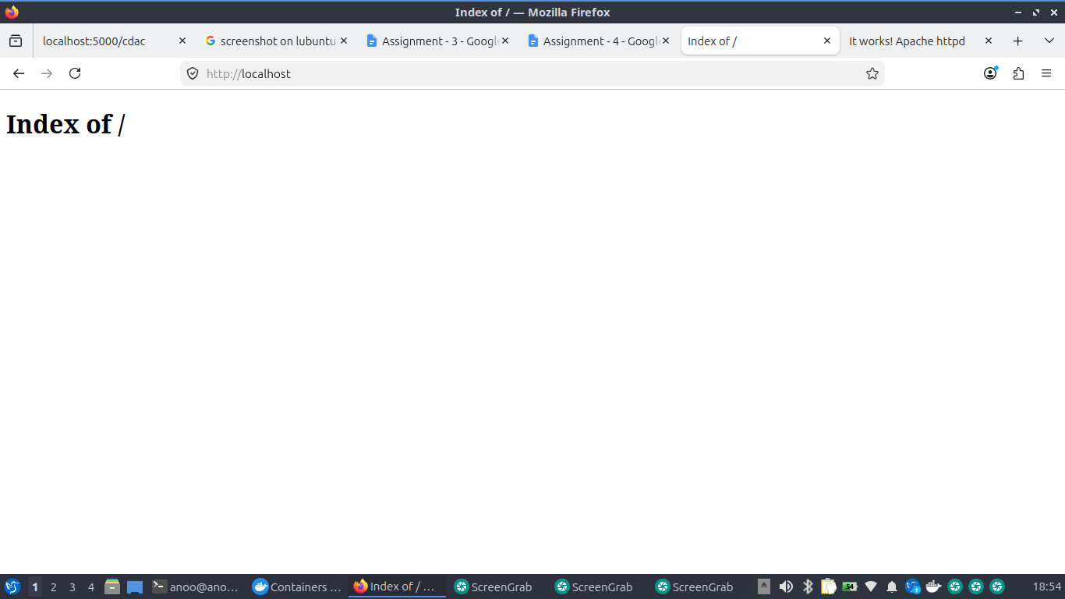
- Go to http://localhost:81 to see the "Web 2" page.
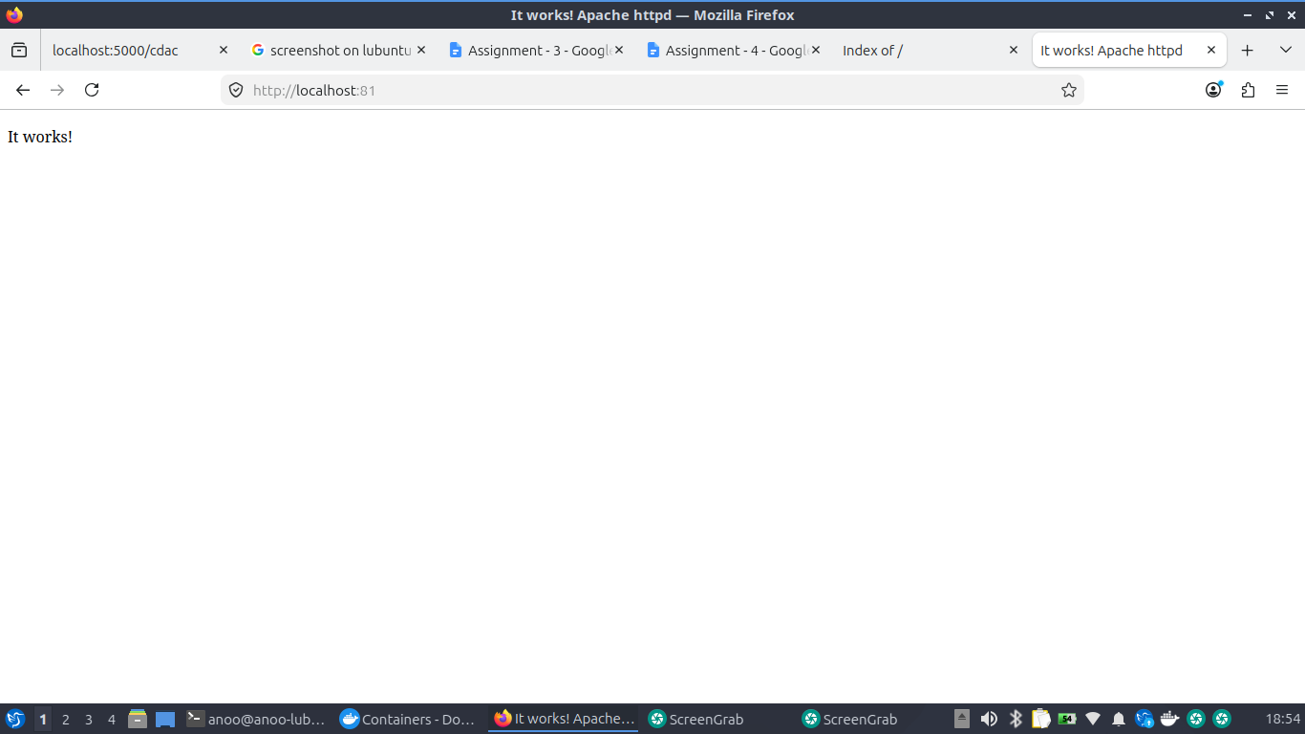
To see if Redis is running, check active containers:
docker ps

